

CHANDIGARH UNIVERSITY
CENTRE FOR DISTANCE & ONLINE EDUCATION

MAJOR PROJECT REPORT ( UID : O24MCA110853 )

Retail Marketing Optimization Systems
A project report submitted in fulfillment of the requirements for the award of the degree of

MASTER OF COMPUTER APPLICATIONS

(Fourth Semester)

Submitted by : Nehal Ojha Under the Guidance of:

Roll No. : O24MCA110853
Batch: July 2024 Batch
Hooghly, West Bengal Mobile No.: 9007500198
Academic Project Supervisor
Department of Computer Applications Centre for Distance & Online Education Chandigarh University

This is to certify that the Major Project entitled "Retail Marketing Optimization Systems" submitted by Nehal Ojha (Roll No: O24MCA110853) in fulfillment of the requirements for the award of the degree of Master of Computer Applications from Chandigarh University, Centre for Distance & Online Education, is a record of bona fide project work carried out under my supervision and guidance.

The matter embodied in this report has not been submitted anywhere else for the award of any other degree or diploma to the best of my knowledge and belief. This project fulfills all software engineering methodologies, systemic modeling, and implementation guidelines specified by the university.

Nehal Ojha
Candidate Signature
Internal Guide / Examiner
Chandigarh University

I, Nehal Ojha, student of Master of Computer Applications (MCA), Fourth Semester, bearing Roll Number O24MCA110853 at Chandigarh University, Centre for Distance & Online Education, hereby declare that the project work presented in this report entitled "Retail Marketing Optimization Systems" is an authentic work carried out by me individually under the guidance of my project supervisor.

I further declare that the source code, implementation parameters, dataset schemas, and software architecture diagrams included in this report have been custom-developed by me. All information, libraries, and frameworks utilized from third-party open-source ecosystems have been properly acknowledged and cited in the bibliography.

Date: June, 2026
Place: Hooghly , West Bengal

Nehal Ojha
Roll No: O24MCA110853

I express my sincere gratitude to my respected project guide for continuous encouragement, valuable suggestions, technical guidance, and constant support throughout the development of this project.
I also thank the Head of the Department and all faculty members of the Department of Computer Applications for providing the necessary facilities and academic environment required for completing this work.
I would like to acknowledge the open-source community, whose learning resources, datasets, and development tools made this project possible. Special thanks are extended to the creator of the reference analytics project that inspired the implementation and helped demonstrate a practical end-to-end data analytics workflow.
Finally, I express my heartfelt gratitude to my parents and friends for their encouragement and moral support during the completion of this project.

Nehal Ojha

ABSTRACT

Modern businesses generate large volumes of customer transaction data every day. However, transforming this raw information into meaningful business intelligence requires a systematic data analytics process. This project presents an end-to-end customer shopping behaviour analysis system developed using Python, SQL, and Power BI.
The proposed system performs data cleaning, pre-processing, exploratory data analysis, database integration, SQL-based business analysis, and interactive dashboard development. Python is used to prepare and clean the dataset before storing it in a relational database. SQL queries are employed to answer important business questions related to customer demographics, purchasing behavior, spending habits, and loyalty. Finally, Power BI is used to build interactive dashboards that help business managers identify trends and make informed decisions.
The developed system demonstrates how multiple data analytics technologies can be integrated into a unified workflow to extract actionable insights from retail customer data. The project also highlights best practices in data visualization, business intelligence, and decision support systems.
Keywords: Data Analytics, SQL, Python, Power BI, Customer Behaviour, Business Intelligence, Dashboard, Data Visualization.

Nehal Ojha Roll No.: O24MCA110853
5

TABLE OF CONTENTS
- INTRODUCTION 8
  - Introduction
  - Background Of Study
  - Problem Statement
  - Objective of Project
  - Scope of Project
  - Significance of Project
  - Project Workflow
  - Organization report
- COMPREHENSIVE LITERATURE REVIEW 11
  - Introduction
  - Customer Behavior Analytics
  - Data Analytics in Retail Industry
  - Python for Data Analytics
  - SQL for Business Analytics
  - Business Intelligence using Power BI
  - Exploratory Data Analysis ( EDA)
  - Existing Systems
  - Proposed Systems
2.10 Research Gap
- SOFTWARE REQUIREMENTS SPECIFICATION (SRS) 15
  - Introduction
  - Purpose
  - Scope
  - Functional Requirements
  - Non-Functional Requirements
  - Hardware Requirements
  - Software Requirements
  - Feasibility Study
  - Assumptions
3.10 Constrains
3.11 Risk Analysis
- SYSTEM ANALYSIS AND DESIGN 19
  - Introduction
  - System Architecture
  - Data Flow Diagram ( DFD )
  - Entity Relationship (ER) Diagram
  - Database Schema
  - Module Design
- SYSTEM IMPLEMENTATION 25
  - Importing Required Libraries
  - Loading the dataset
  - Previewing the dataset
  - Understanding data structure
  - Statistical Summary
  - Missing value deletion
  - Data Preprocessing
  - Handling missing values
  - Renaming column names
5.10 Feature Engineering
5.11 Removing redundant attributes
5.12 Database Integration
5.13 Exporting data to SQL
5.14 SQL business analysis
5.15 Power BI Dashboard
- CONCLUSION AND FUTURE SCOPE 37
  - Conclusion
  - Future Scope
  - Learning outcomes
  - Final Remarks
  - Appendices

NEHAL OJHA
Roll No.: O24MCA110853
7

INTRODUCTION

Introduction
The rapid growth of digital commerce has resulted in organizations collecting enormous volumes of customer-related information. Every purchase, website visit, product search, and customer interaction contributes to a growing repository of data. While this information holds significant business value, its true potential can only be realized through systematic analysis and interpretation.
Data analytics has emerged as one of the most influential technologies for transforming raw data into meaningful business insights. Modern organizations rely heavily on analytical techniques to understand customer behavior, predict future trends, improve operational efficiency, and support strategic decision-making. Companies such as Amazon, Walmart, Flipkart, and many other retail organizations extensively use customer analytics to enhance user experience, optimize inventory management, and increase profitability.
This project focuses on developing an end-to-end customer shopping behavior analysis system using three widely adopted technologies: Python, SQL, and Power BI. Python is employed for data preprocessing, cleaning, and exploratory analysis. SQL facilitates efficient storage and retrieval of structured data while enabling the execution of complex business queries. Power BI serves as the visualization platform, presenting analytical findings through interactive dashboards that support data-driven decision-making.
The project demonstrates the complete workflow typically followed by professional data analysts, from importing raw data to presenting actionable business insights through dashboards.

1.2 Background of Study
Customer behavior analysis is the process of examining purchasing patterns, preferences, demographic characteristics, and transactional history to understand consumer decision-making. Businesses increasingly depend on such analyses to improve customer satisfaction, identify high-value customers, and optimize marketing strategies.
Traditional reporting methods often fail to provide timely insights due to their dependence on manual data processing. Contemporary data analytics platforms integrate programming languages, database systems, and visualization tools to automate analytical workflows. Python provides robust libraries for statistical analysis and data manipulation, SQL enables efficient querying of structured datasets, and Power BI offers advanced visualization capabilities that transform analytical results into interactive reports.
This integration significantly enhances an organization's ability to monitor key performance indicators (KPIs), identify emerging trends, and respond quickly to changing customer behavior.

1.3 Problem Statement
Retail organizations generate large quantities of customer transaction data every day. Despite having access to such information, many businesses struggle to transform raw datasets into actionable knowledge due to inadequate analytical infrastructure, inconsistent data quality, and limited visualization capabilities.
The absence of integrated analytics often results in:
- Difficulty identifying profitable customer segments.
- Limited understanding of purchasing behavior.
- Inefficient marketing campaigns.
- Poor inventory planning.
- Reduced customer retention.
- Delayed managerial decision-making.
This project addresses these challenges by implementing a comprehensive analytics workflow that combines Python, SQL, and Power BI to generate meaningful business intelligence.

1.4 Objectives
The primary objectives of this project are:
- To develop an end-to-end customer behavior analysis system.
- To preprocess and clean customer shopping data using Python.
- To perform exploratory data analysis for identifying patterns and trends.
- To store processed data in a relational SQL database.
- To answer business-oriented questions using SQL queries.
- To develop interactive dashboards using Power BI.
- To assist decision-makers in identifying profitable customer segments.
- To provide meaningful visualizations for strategic planning.

Scope of the Project
The scope of the project includes:
- Importing raw customer shopping data.
- Data preprocessing and cleaning.
- Handling missing and duplicate records.
- Exploratory Data Analysis.
- SQL database creation.
- Business query implementation.
- Interactive dashboard development.
- Business insight generation.
- Performance visualization.

The project does not include predictive machine learning models or real-time streaming analytics; its focus is descriptive and diagnostic analytics.

Significance of the Project
This project demonstrates the practical application of modern data analytics tools in solving real-world business problems. It enables organizations to gain a deeper understanding of customer behavior and purchasing trends, thereby supporting informed strategic decisions.
Academically, the project provides hands-on experience with Python, SQL, and Power BI while illustrating a complete analytics lifecycle suitable for industry-oriented learning.

Project Workflow
The project follows the workflow below:
- Data Collection
- Data Import using Python
- Data Cleaning
- Exploratory Data Analysis
- SQL Database Creation
- Data Loading into SQL
- SQL-Based Business Analysis
- Power BI Dashboard Development
- Business Insight Generation
- Report Preparation

Organization of report
The report is organized into the following chapters:
- Chapter 1: Introduction
- Chapter 2: Literature Review
- Chapter 3: Software Requirement Specification
- Chapter 4: System Design and Database Design
- Chapter 5: Project Implementation
- Chapter 6: Dashboard Development and Business Insights
- Chapter 7: Testing and Results
- Chapter 8: Conclusion and Future Scope

COMPREHENSIVE LITERATURE REVIEW

2.1 Introduction
The rapid advancement of digital technologies has transformed the way organizations collect, store, and analyze customer information. Every transaction, product search, online purchase, and customer interaction generates valuable data that can be analyzed to improve business performance. Data analytics has therefore become one of the most significant technological domains for modern organizations. It enables companies to identify customer preferences, forecast demand, optimize marketing strategies, and improve customer satisfaction.
Retail industries are increasingly adopting data-driven decision-making to remain competitive. Instead of relying solely on intuition, businesses use statistical analysis, database systems, and visualization tools to understand customer behavior. Technologies such as Python, SQL, and Power BI have become industry standards due to their efficiency, flexibility, and scalability.
This chapter reviews previous research in customer behavior analysis, business intelligence, data visualization, database management systems, and exploratory data analysis. The review establishes the academic foundation for the proposed system and demonstrates how modern analytical tools contribute to solving real-world business problems.

2.2 Customer Behavior Analytics

Customer behavior analytics refers to the systematic study of customer interactions, purchasing habits, preferences, and decision-making processes. Organizations analyze these patterns to understand what motivates customers to purchase products and how they interact with various services.
Behavioral analysis generally includes:
- Purchase frequency analysis
- Customer segmentation
- Spending pattern analysis
- Product preference identification
- Seasonal buying trends
- Customer loyalty evaluation
- Revenue contribution analysis
Retail organizations utilize these analytical methods to personalize recommendations, optimize inventory management, improve marketing campaigns, and increase customer retention.

2.3 Data Analytics in retail industry
The retail industry generates enormous quantities of structured and unstructured data every day. Effective utilization of this information enables businesses to improve operational efficiency while maximizing profitability.
Major applications include:
- Sales forecasting
- Customer segmentation
- Inventory optimization
- Product recommendation systems
- Customer lifetime value analysis
- Market basket analysis
- Fraud detection
- Promotional campaign analysis
Modern retail companies increasingly depend upon business intelligence platforms for real-time monitoring of organizational performance.

2.4 Python for Data Analytics
Python has become the most widely used programming language in the field of data analytics due to its simplicity and extensive ecosystem of libraries.
Important Python libraries include:

Pandas
Pandas provides powerful data structures for handling tabular data. It supports filtering, grouping, aggregation, missing value handling, duplicate removal, merging, and statistical operations.
Applications:
- Data cleaning
- Data preprocessing
- Dataset transformation
- Feature engineering

NumPy
NumPy offers high-performance numerical computation through multidimensional arrays.

Applications:
- Mathematical operations
- Matrix computation
- Statistical calculations

Matplotlib
Matplotlib is widely used for creating visual representations of data.
Common charts include:
- Line graphs
- Histograms
- Scatter plots
- Pie charts
- Bar graphs

Seaborn
Seaborn extends Matplotlib by providing aesthetically pleasing statistical graphics.
Used for:
- Correlation heatmaps
- Pair plots
- Distribution plots
- Box plots
- Violin plots

2.5 SQL for Business Analytics
Structured Query Language (SQL) is the standard language for managing relational databases. SQL enables analysts to retrieve meaningful information from structured datasets using efficient query operations.
Major SQL operations include:
- SELECT
- INSERT
- UPDATE
- DELETE
- GROUP BY
- ORDER BY
- HAVING

- Aggregate Functions
- Window Functions
- Joins
- Subqueries
Business organizations utilize SQL to generate reports regarding sales performance, customer segmentation, employee productivity, financial transactions, and inventory management.

2.6 Business Intelligence using PowerBI
Power BI is a business intelligence platform developed by Microsoft that converts raw datasets into interactive dashboards and reports.
Major features include:
- Interactive Dashboards
- KPI Cards
- Slicers
- Drill-through Analysis
- Geographic Maps
- Time-Series Charts
- Forecasting
- Report Sharing
Power BI enables business managers to monitor organizational performance in real time through visually intuitive reports.

2.7 Exploratory Data Analysis (EDA)
EDA is the process of understanding a dataset before performing advanced analysis.
Common EDA activities include:
- Missing value identification
- Duplicate detection
- Statistical summary
- Outlier analysis
- Correlation analysis
- Distribution analysis
- Trend identification
EDA ensures data quality and improves the reliability of subsequent analytical models.

2.8 Existing Systems
Traditional retail reporting systems primarily generate static reports that require manual interpretation.

Limitations
- Static reports
- Lack of visualization
- Delayed reporting
- Limited interactivity
- Poor scalability
- Manual analysis

2.9 Proposed System
The proposed system integrates Python, SQL, and Power BI into a unified analytical workflow.
Advantages include:
- Automated preprocessing
- Efficient SQL querying
- Interactive visualization
- Business insight generation
- Better decision support
- Improved reporting efficiency

2.10 Research Gap
Despite significant progress in business intelligence technologies, many small and medium-sized enterprises continue to face challenges in implementing complete analytical workflows.
Common research gaps include:
- Lack of integrated analytics
- Poor visualization
- Inadequate data preprocessing
- Limited automation
- Absence of standardized workflows
The proposed project addresses these issues by developing a complete end-to-end analytics pipeline.

SOFTWARE REQUIREMENT SPECIFICATION (SRS)

3.1 Introduction

A Software Requirement Specification (SRS) defines the functional and non-functional requirements of a software system. It serves as a blueprint for designing, developing, testing, and maintaining the application.

The proposed Customer Shopping Behavior Analysis System aims to provide an integrated platform for customer data analysis using Python, SQL, and Power BI.

3.2 Purpose

The purpose of the system is to:
- Import customer shopping data.
- Clean and preprocess datasets.
- Store processed information in SQL databases.
- Execute business queries.
- Generate interactive dashboards.
- Support business decision-making

3.3 Scope
The software covers the complete lifecycle of customer data analysis.
Major modules include:
- Data Import
- Data Cleaning
- Data Transformation
- SQL Database
- Business Analytics
- Dashboard Development
- Report Generation

3.4 Functional Requirements

REQ ID | DETAILED OPERATIONAL SCOPE & ALGORITHMIC BOUNDS
FR-1 | Import customer dataset
FR-2 | Validate dataset integrity
FR-3 | Handle missing values
FR-4 | Remove duplicate records
Fr-5 | Perform Exploratory Data Analysis
FR-6 | Create SQL Database
FR-7 | Insert clean records
FR-8 | Execute Analytical SQL queries
FR-9 | Generate Power BI Dashboard
FR-10 | Display Business Insights

3.5 Non-functional Requirements

REQ ID | DETAILED OPERATIONAL SCOPE & ALGORITHMIC BOUNDS
Performance | System should process large datasets efficiently
Relaibility | System should produce consistent analytical result
Scalability | Future datasets can be incorporated without significant redesign.
Security | Database access should be restricted to authorized users.
Maintainability | Modules should be independently maintainable.
Probability | System should execute on Windows, Linux, and macOS environments where the required software is installed.

3.6 Hardware Requirements

Hardware Component | Recommended Specification
Processor Type | Intel Core i5 core and above
System Memory (RAM) | Minimum 8GB
Storage Capacity | 255 GB SSD
Display | 1366*768 or higher

3.7 Software Requirements

Software Component | Version
Python | 3.x
Jupyter Notebook | latest
MySQL | 8.x
Power BI Desktop | Latest
Windows | Windows 10/11

3.8 Feasibility study

Technical Feasibility
The required technologies are open-source or freely available for educational use and are widely adopted in the data analytics industry.

Economic Feasibility
Development cost is minimal because the project primarily uses free tools and an openly available dataset.

Operational Feasibility
The proposed system is easy to use and provides actionable insights through intuitive dashboards.

Schedule Feasibility
The project can be completed within a typical academic semester with proper planning.

3.9 Assumptions
- Input data is available in CSV format.
- Users have basic knowledge of SQL and Python.
- Power BI Desktop is installed.
- Database connectivity is properly configured.

3.10 Constraints
- The project focuses on descriptive analytics and dashboard reporting.
- Predictive machine learning models are outside the current scope.
- Dashboard functionality depends on the quality and completeness of the input data.

3.11 Risk Analysis
Potential risks include:
- Poor data quality.
- Database connection failures.
- Incomplete datasets.
- Incorrect SQL queries.
- Software compatibility issues.
Mitigation strategies involve data validation, regular backups, query testing, and environment verification.

SYSTEM ANALYSIS AND DESIGN

4.1 Introduction
System analysis and design is a critical phase in software development that defines the overall structure, workflow, and interactions of a system before implementation. For this project, the design focuses on integrating data collection, preprocessing, SQL-based storage and analysis, and interactive visualization into one coherent analytics pipeline.
The objective is to ensure that each stage of the workflow transforms raw customer shopping data into meaningful business insights in a structured, maintainable, and scalable manner.

4.2 System Architecture

The proposed system follows a layered architecture consisting of five major components:

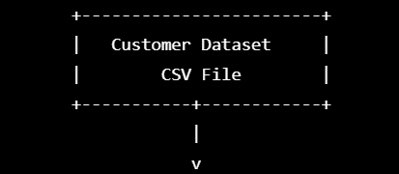

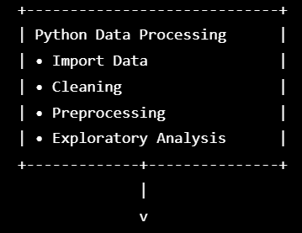
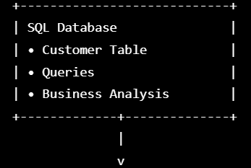
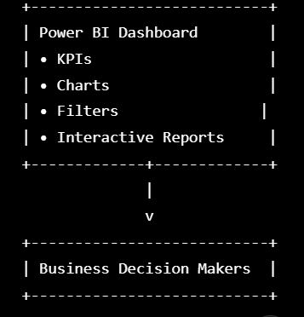

Explanation
- CSV Dataset serves as the raw data source.
- Python performs preprocessing, cleansing, and exploratory analysis.
- The cleaned data is stored in a SQL database.
- SQL is used to answer business-related questions through structured queries.
- Power BI visualizes the analytical results through interactive dashboards.

4.3 Data Flow Diagram ( DFD )

Level 0 DFD (Context Diagram)

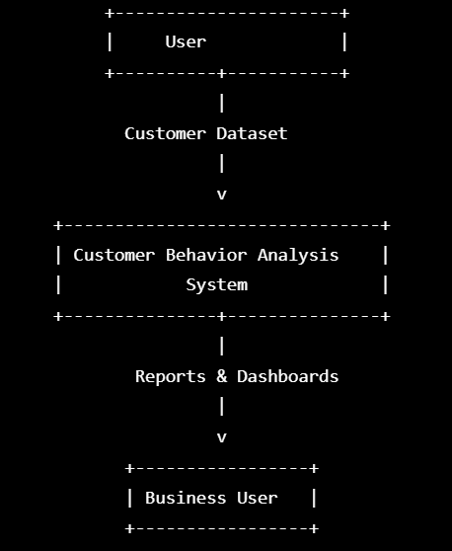

Description
The customer dataset is provided to the analytics system, which processes the data and produces dashboards and analytical reports for business users.
Level 1 DFD
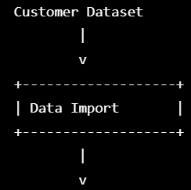

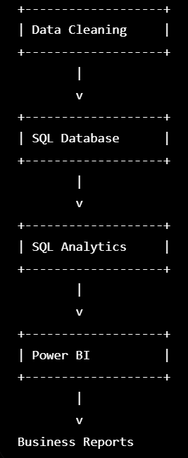

4.4 Entity relationship (ER) Diagram

The customer behavior dataset primarily contains customer demographic details and shopping information. A simplified conceptual ER model is shown below.

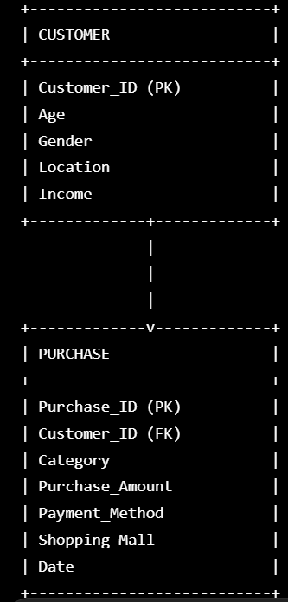

4.5 Database schema

CUSTOMER Table :

Field | Type
Customer_ID | INT
Age | INT
Gender | VARCHAR
Location | VARCHAR
Income | FLOAT

PURCHASE Table :

Field | Type
Purchase_ID | INT
Customer_ID | INT
Category | VARCHAR
Purchase_Amount | DECIMAL
Payment_Method | VARCHAR
Shopping_Mall | VARCHAR
Purchase_Date | DATE

4.6 Module Design
The proposed system consists of six independent modules.

Module 1

Data Import Module
Responsibilities:
- Import CSV
- Read dataset
- Validate records

Module 2

Data Cleaning Module
Responsibilities:
- Missing values
- Duplicate removal
- Incorrect values
- Data conversion

Module 3

Exploratory Data Analysis
Responsibilities:
- Statistical summary
- Distribution analysis
- Correlation
- Visualization

Module 4

SQL Analytics
Responsibilities:
- Store data
- Execute SQL
- Generate KPIs
- Customer segmentation

Module 5

Dashboard Module
Responsibilities:
- Interactive charts
- Filters
- KPI cards
- Drill-down reports

Module 6

Report Generation
Responsibilities:
- Business insights
- Dashboard interpretation
- Final reporting

SYSTEM IMPLEMENTATION

5.1 Importing Required Libraries



Explanation:
- Pandas is used for loading and manipulating tabular data.
- NumPy provides numerical computation functions.
- Matplotlib generates charts and graphs.
- Seaborn creates advanced statistical visualizations.
These libraries provide the necessary tools for preprocessing, analysis, and visualization.

5.2 Loading the dataset

Explanation:
The read_csv() function imports the CSV dataset into memory as a DataFrame. This DataFrame acts as the primary data structure used throughout the implementation.
Once loaded successfully, the dataset is ready for exploration and preprocessing.

5.3 Previewing the dataset



Explanation:
The head() function displays the first five rows of the dataset. This helps verify that the dataset has been imported correctly and provides an overview of the available attributes.
Expected Output:
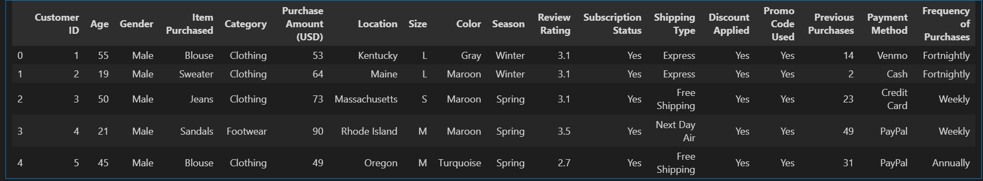

5.4 Understanding Data structure



Explanation: This function displays:
- Total number of records
- Total number of columns
- Data type of each column
- Number of non-null values
- Memory usage
The information obtained helps identify missing values and inappropriate data types that require preprocessing.
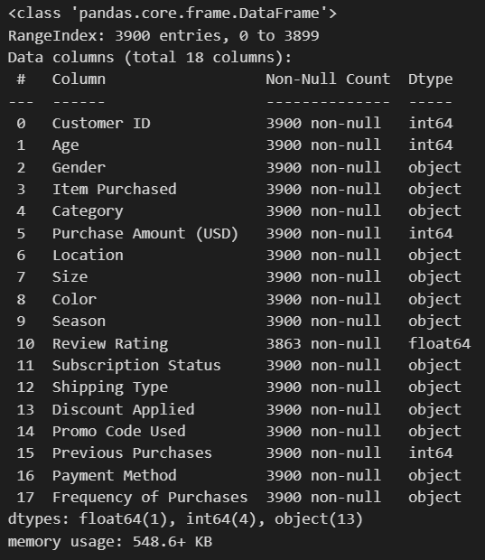

5.5 Statistical Summary



Explanation:
The statistical summary provides numerical measures such as:
- Mean
- Standard deviation
- Minimum value
- Maximum value
- Quartiles
For categorical variables, it displays the most frequent values and unique counts. These statistics provide an initial understanding of customer demographics and purchasing behaviour.

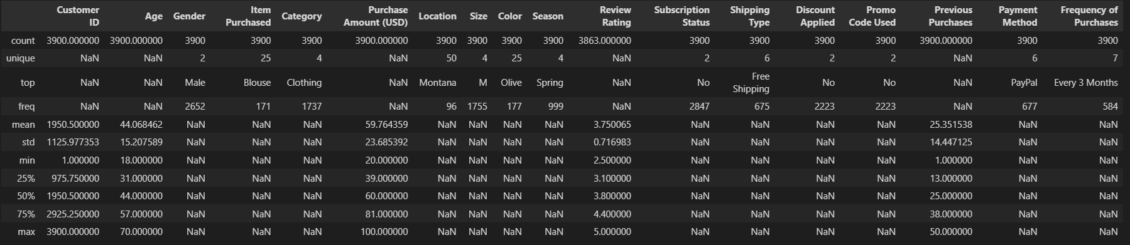

5.6 Missing Value Deletion



Explanation:
The isnull() function identifies missing entries in each column, while sum() counts the total missing values. During analysis, the Review Rating column was found to contain missing values that required preprocessing.
Identifying missing data at this stage ensures the reliability of subsequent analysis.

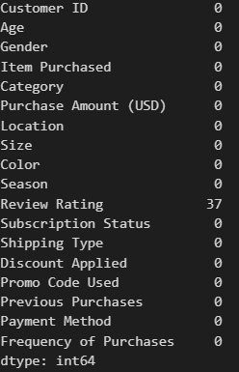

5.7 Data Preprocessing
Data preprocessing is an essential step in data analytics because raw datasets often contain inconsistencies such as missing values, redundant columns, and non-standard naming conventions. In this project, preprocessing was carried out using the Pandas library to improve data quality before storing the dataset in the SQL database.
The preprocessing tasks performed include:
- Handling missing values
- Renaming column names
- Feature engineering
- Removing redundant attributes

5.8 Handling Missing Values

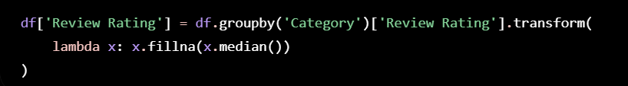

Explanation:
Instead of removing rows with missing values, the missing ratings were replaced using the median review rating of the corresponding product category.
This method was preferred because:
- It preserves all customer records.
- It avoids bias introduced by deleting observations.
- Median values are less affected by extreme ratings than the mean.
After replacing the missing values, the dataset was checked again to ensure that no null values remained.
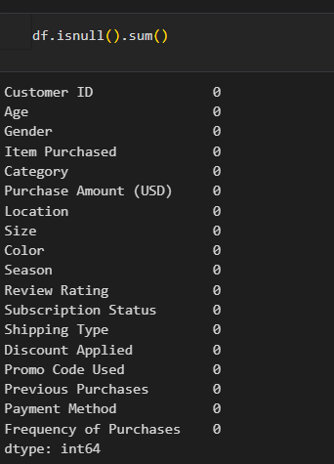

5.9 Renaming Column names

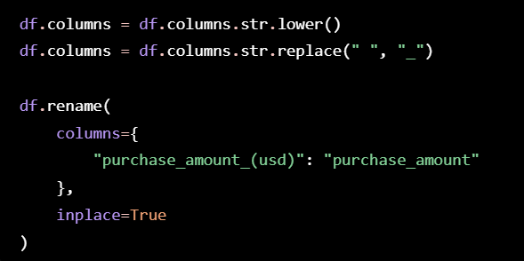

Explanation
Renaming columns simplifies coding and prevents syntax errors caused by spaces or special characters. It also ensures compatibility with SQL table names and Power BI fields.
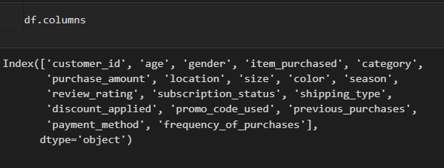

5.10 Feature Engineering

(a) Age Group Creation
The customer age was divided into four categories using quantile-based binning.
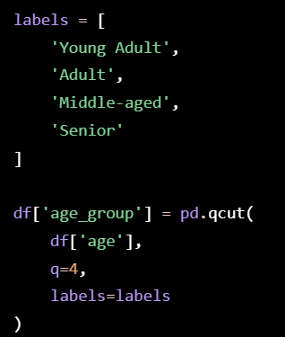

Explanation
The new age_group attribute simplifies demographic analysis and enables comparison of purchasing behavior across different age segments.

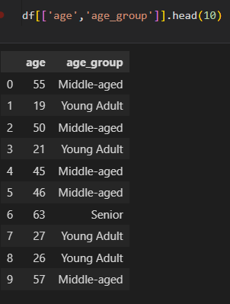

(b) Purchase Frequency Conversion
The purchase frequency values were converted from categorical text into numerical values representing the approximate number of days between purchases.
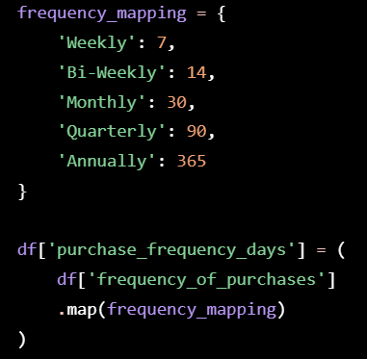

Explanation
The numerical representation enables statistical analysis, correlation studies, and visualization of purchase intervals.

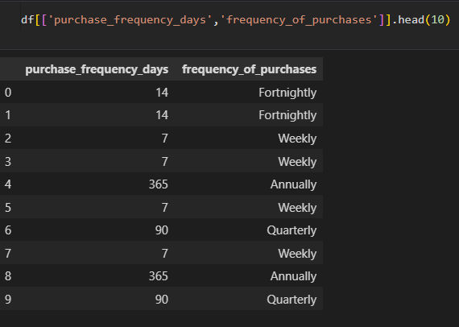

5.11 Removing Redundant Attributes

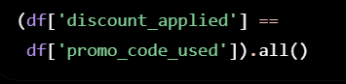

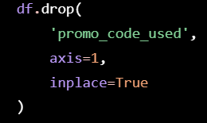

Explanation
Removing duplicate information reduces storage requirements and simplifies the dataset without affecting analytical results.
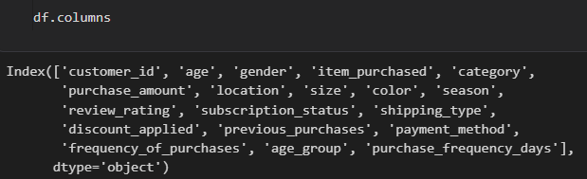

5.12 Database Integration
After preprocessing, the cleaned dataset is stored in a relational database for structured querying and business analysis.
The project demonstrates database connectivity using SQLAlchemy with PostgreSQL (and similar logic can be applied for MySQL).
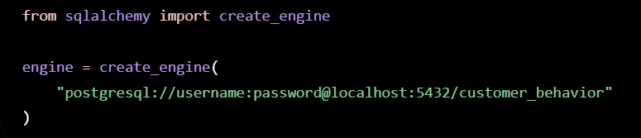

Explanation
SQLAlchemy provides a convenient interface for establishing a database connection. The connection string specifies the database type, username, password, host, port, and database name.
Once connected, the processed DataFrame can be exported directly to SQL tables.

5.13 Exporting Data to SQL

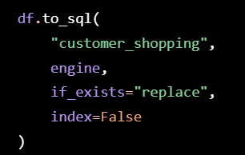

Explanation
The to_sql() function automatically creates the table (if necessary) and inserts all processed records into the database. This eliminates manual data entry and ensures consistency between Python and SQL.

5.14 SQL Business Analysis

Query 1: Total Customers





Purpose: Determines the total number of customer records.

Query 2: Average Purchase Amount

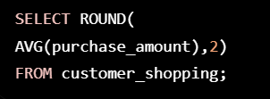

Purpose: Calculates the average spending per customer.

Query 3: Category wise sales

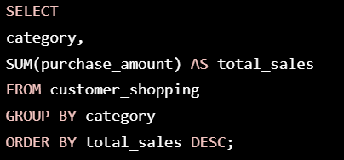

Purpose: Identifies the highest revenue-generating product categories.

Query 4: Payment method analysis

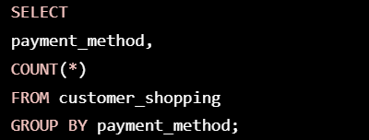

Purpose: Shows the most frequently used payment methods.

Query 5: Customer Age group distribution

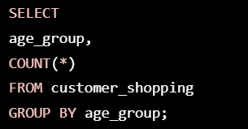

Purpose: Analyzes the demographic distribution of customers.

5.15 Power BI Dashboard
The processed SQL data is imported into Power BI to create an interactive dashboard. The dashboard enables users to explore customer behavior through visualizations and filters.
The dashboard includes:
- KPI Cards
- Product Category Sales
- Customer Age Group Distribution
- Payment Method Analysis
- Purchase Trends
- Interactive Filters
These visualizations support quick interpretation of business performance and customer purchasing patterns
1. Sales as per Subscription Status as Yes and Gender as Male
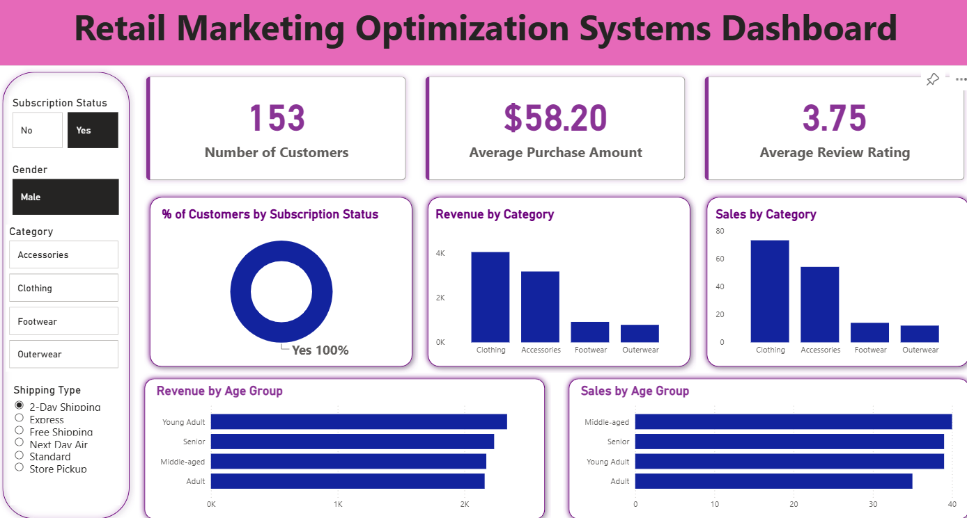.

2. Sales as per Subscription Status as No and Gender as Female and Category as Accessories
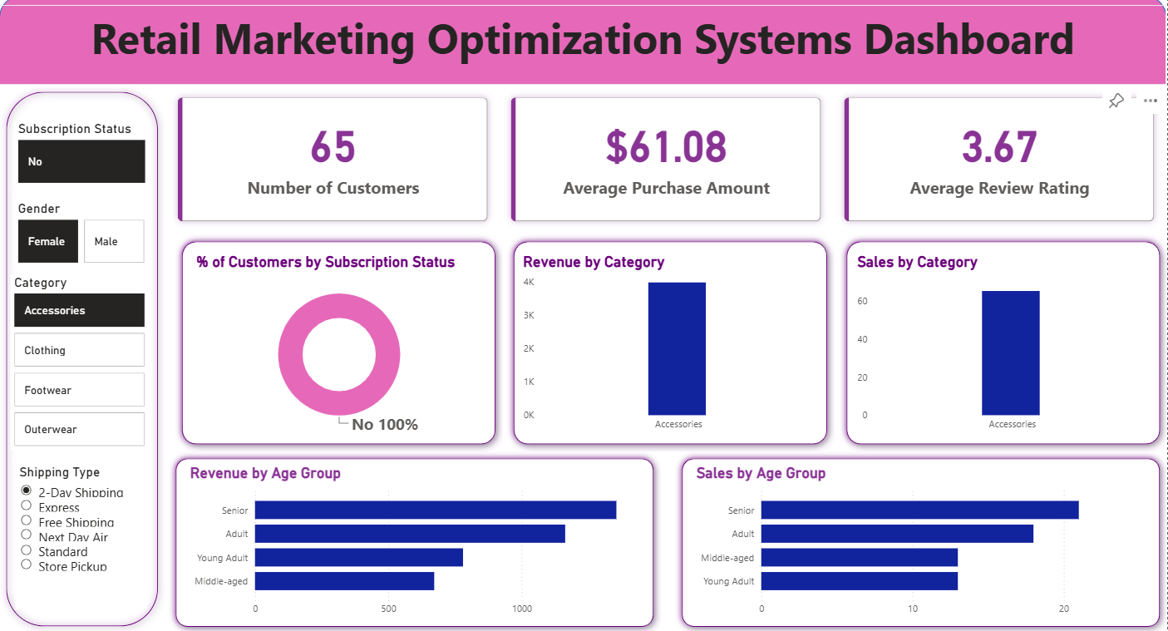
3. Sales as per Subscription Status as No and Gender as Female and Category as Clothing
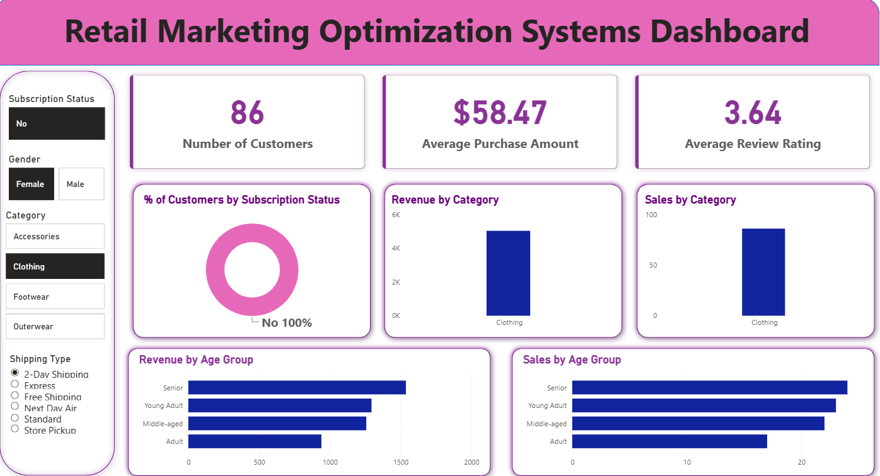

4. Sales as per Subscription Status as No and Gender as Female and Category as Footwear
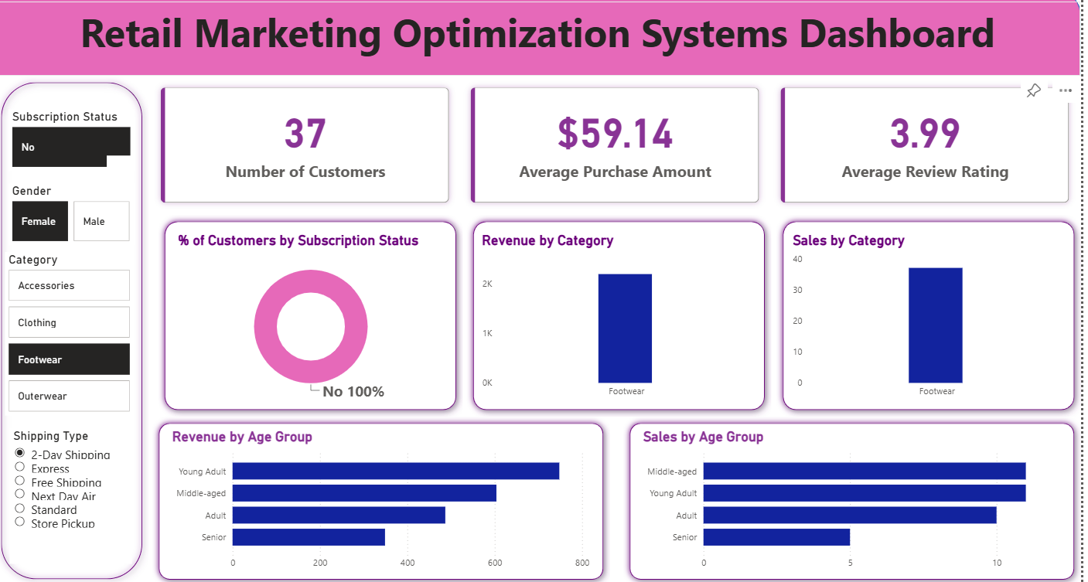
5. Sales as per Subscription Status as No and Gender as Female and Category as Outerwear and Shipping as Store Pickup.
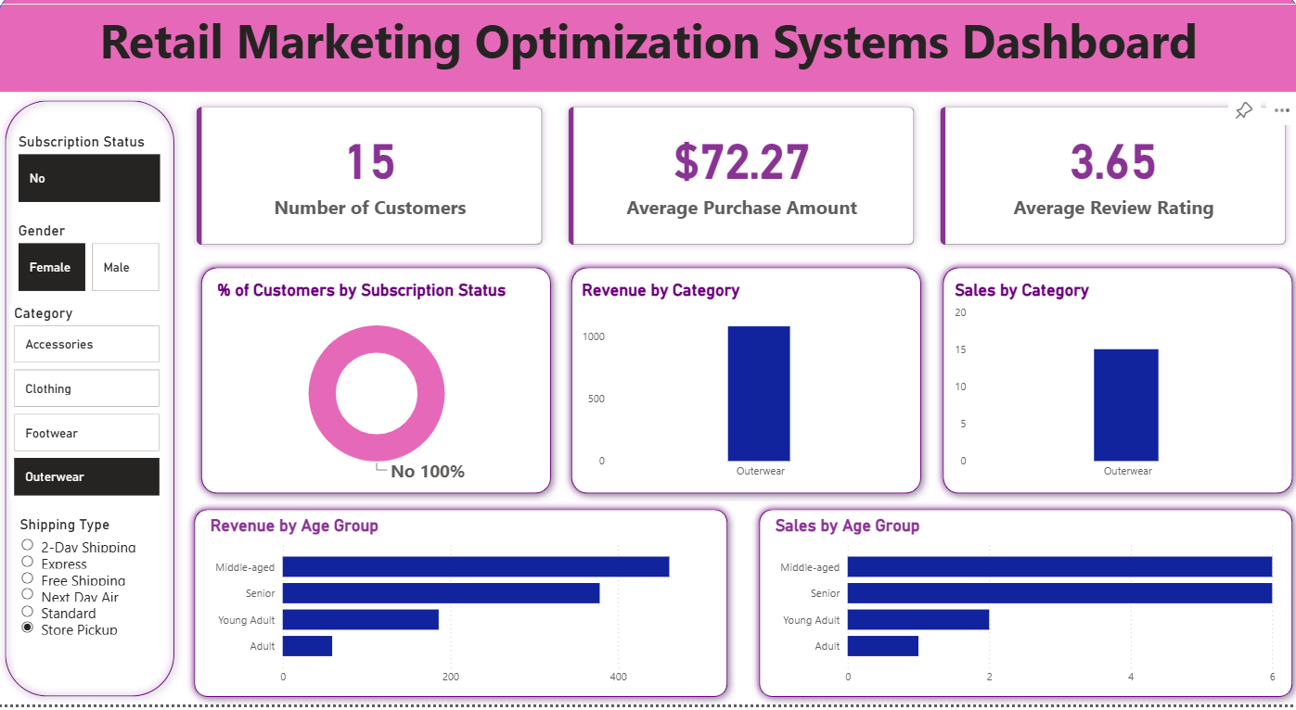

CONCLUSION AND FUTURE SCOPE

6.1 Conclusion
The Customer Shopping Behavior Analysis using SQL, Python and Power BI project demonstrates a complete end-to-end data analytics workflow suitable for modern retail environments. Beginning with raw customer shopping data, the system performs data cleaning, exploratory analysis, database integration, business querying, and interactive visualization.
Python enables efficient preprocessing and statistical analysis, SQL provides reliable storage and retrieval of structured information, and Power BI transforms analytical results into intuitive dashboards. Together, these technologies support informed decision-making by highlighting purchasing trends, customer demographics, product performance, and key business indicators.
The project successfully achieves its primary objectives:
- Data preprocessing and cleaning.
- Exploratory data analysis.
- SQL-based business analytics.
- Interactive dashboard creation.
- Business insight generation.
The integrated approach presented in this project reflects industry-standard practices in data analytics and demonstrates the practical application of multiple technologies to solve real-world business problems.

6.2 Future Scope
The proposed system can be enhanced in several ways to increase its analytical capabilities:

Machine Learning Integration
Implement predictive models for customer segmentation, sales forecasting, and personalized product recommendations.

Real-Time Analytics
Integrate streaming platforms to analyze live transactional data.

Cloud Deployment
Deploy the solution on cloud platforms such as Microsoft Azure, AWS, or Google Cloud to improve scalability and accessibility.

Natural Language Querying
Allow users to ask business questions using natural language, enabling non-technical stakeholders to interact with the system more easily.

Advanced Dashboards
Incorporate additional KPIs, forecasting visuals, and automated alerts for enhanced decision support.

Data Warehouse Integration
Extend the system to support enterprise-scale data warehouses and multi-source data integration.

6.3 Learning Outcomes
This project provides practical experience in:
- Data preprocessing with Python.
- Exploratory Data Analysis (EDA).
- Relational database design and SQL querying.
- Business intelligence dashboard development.
- Data visualization techniques.
- End-to-end analytics workflow implementation.
- Report writing and presentation of analytical findings.

6.4 Final Remarks

The project demonstrates how modern analytics tools can transform raw retail data into meaningful business intelligence. By combining Python, SQL, and Power BI, the proposed system offers a scalable and effective solution for understanding customer shopping behavior and supporting strategic business decisions

6.5 Appendices
The appendix section will contain:
- Representative Python code snippets.
- Representative SQL queries.
- Power BI dashboard screenshots.
- Dataset schema.
- Additional tables and figures.
- Glossary of key terms.

BIBLIOGRAPHY
- Elmasri, R., & Navathe, S. B. (2017). Fundamentals of Database Systems (7th ed.). Pearson Education.
- Silberschatz, A., Korth, H. F., & Sudarshan, S. (2019). Database System Concepts (7th ed.). McGraw-Hill Education.
- Microsoft Corporation. (2025). Power BI Documentation. Available at: https://learn.microsoft.com/power-bi/
- Pandas Development Team. (2025). Pandas Documentation. Available at: https://pandas.pydata.org/docs/
- NumPy Developers. (2025). NumPy User Guide. Available at: https://numpy.org/doc/
- Matplotlib Development Team. (2025). Matplotlib Documentation. Available at: https://matplotlib.org/stable/
- Seaborn Development Team. (2025). Seaborn Documentation. Available at: https://seaborn.pydata.org/
- SQLAlchemy Authors. (2025). SQLAlchemy Documentation. Available at: https://docs.sqlalchemy.org/
- PostgreSQL Global Development Group. (2025). PostgreSQL Documentation. Available at: https://www.postgresql.org/docs/
- Python Software Foundation. (2025). Python 3 Documentation. Available at: https://docs.python.org/3/
- Kaggle. (2025). Customer Shopping Trends Dataset. Available at: https://www.kaggle.com/
- Jupyter Development Team. (2025). Project Jupyter Documentation. Available at: https://jupyter.org/documentation
- PostgreSQL Global Development Group. (2025). psycopg2 Documentation. Available at: https://www.psycopg.org/docs/
Git Hub Repository - https://github.com/Nehal6787/Retail-Marketing-Optimization-Systems.git

